The Littletons School Uniform Guide


Please find attached the uniform guidelines for The Littletons First School. Please note that your child will not require every item listed – in some case there are options to choose from, whilst keeping the same colour scheme.
The items with the red stars next to them are available with a school logo from The School Shop in Evesham. We do not require any of our uniform to have the school logo.
Some of the uniform will only be required in hot or cold weather. There is no set time that we change from summer to winter uniform.
Watches (not smart watches) and stud earring may be worn to school. No other jewellery is permitted, for safety reasons. The only exceptions are health bracelets and items of religious significance.
Make-up and nail varnish should not be worn to school.
Please ensure that every item of uniform is named clearly so that lost uniform can be easily returned.
We will run uniform ‘swap-shops’ throughout the year. You can swap uniform that no longer fits your child for a bigger size or replace missing uniform. We ask that donated uniform is of good quality and clean (it does not need to have the school logo). This is an initiative that is designed to support families at The Littletons and to reduce clothing waste. It is free to use and can be accessed by all families at the school. To request items of uniform, please fill in this online form.

The Littletons School Uniform
Reception to Year 5

  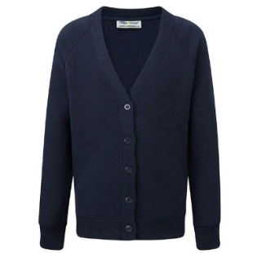 | 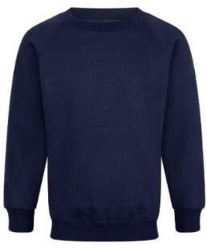 | 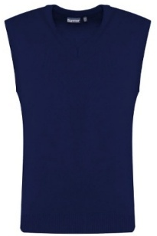
Navy cardigan * | Navy jumper * | Navy tank top

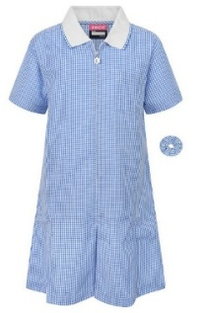 | 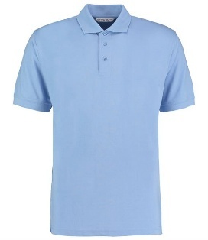 | 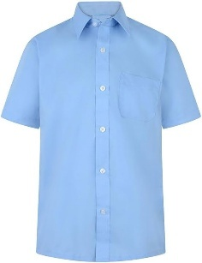
Light blue summer dress | Light blue polo shirt * | Light blue short-sleeved shirt

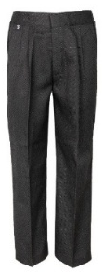 | 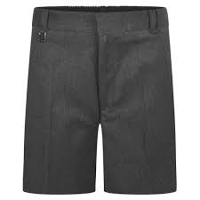 | 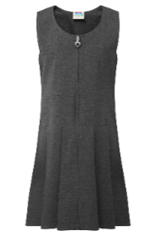 | 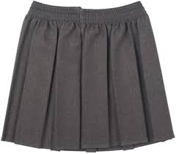
Dark grey trousers | Dark grey shorts | Dark grey dress/ pinafore | Dark grey skirt

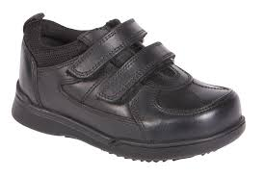 | 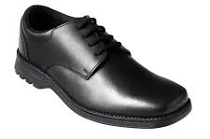 | 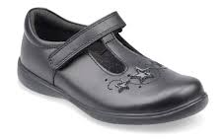
Smart black shoes (please only send lace-up shoes if children can tie the laces themselves)

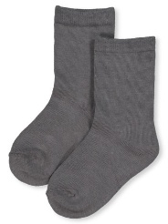 | 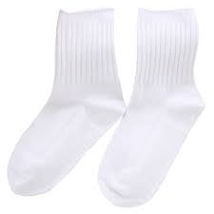 | 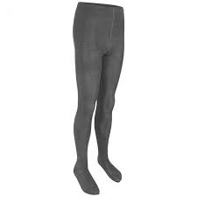
Plain socks or tights (grey or white)

* | Item with logos available from The School Shop, Evesham (optional)

The Littletons PE Kit
Reception to Year 5

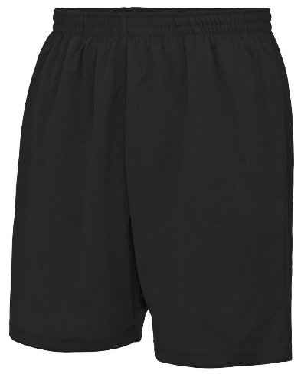 | 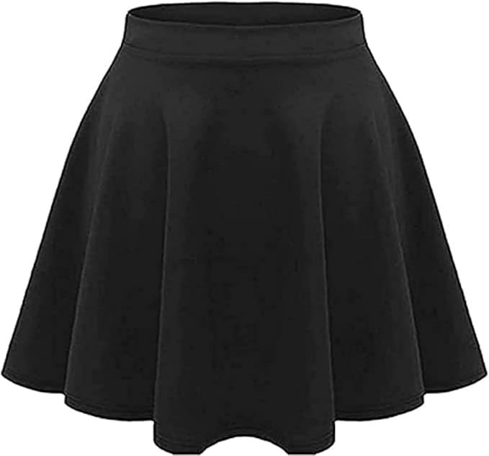 | 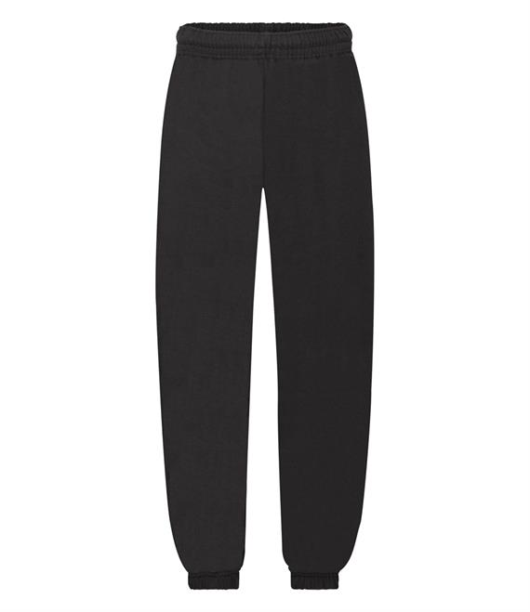
Black PE shorts | Black PE skirt | Black jogging bottoms - cold weather

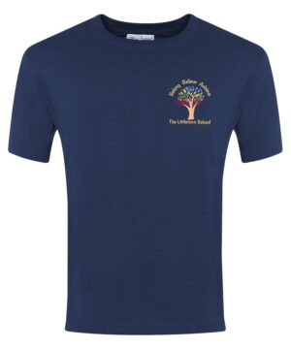 | 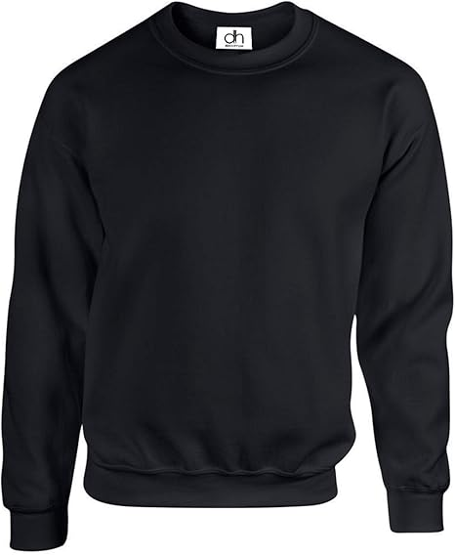 | 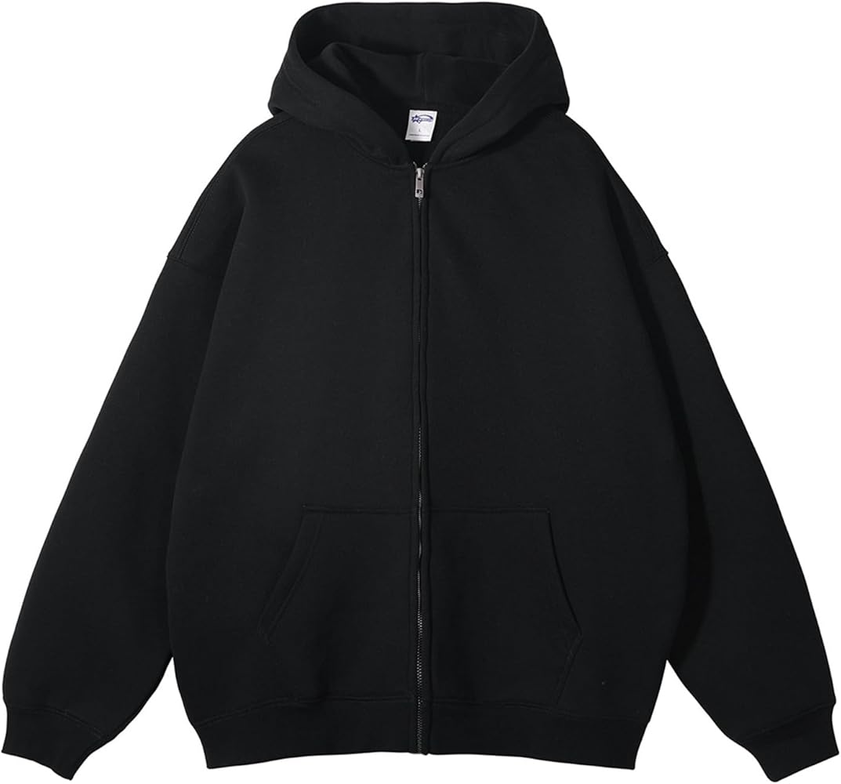
Navy t-shirt * | Black PE jumper – cold  weather * | Black zip-up PE jumper – cold weather *

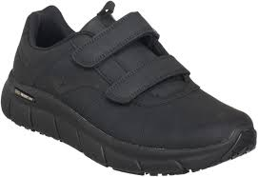 | 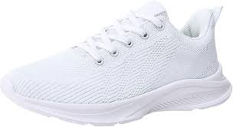 | 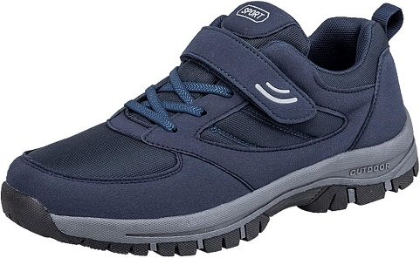
Plain sports trainers – (please only send lace-up trainers if children can tie the laces themselves)

* | Item with logos available from The School Shop, Evesham (optional)

The Littletons School Uniform
Nursery

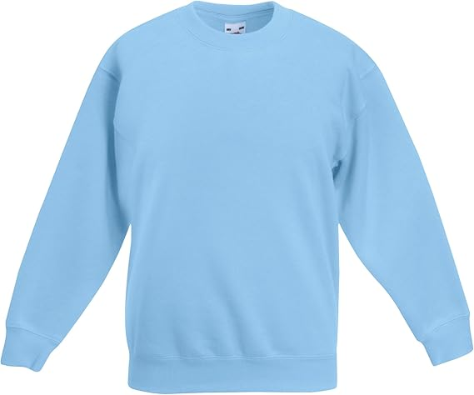 | 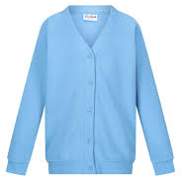 | 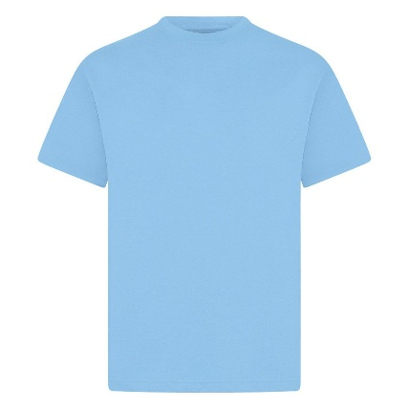
Light blue jumper * | Light blue cardigan * | Light blue t-shirt *

* | Item with logos available from The School Shop, Evesham (optional)

Children in Nursery can wear any other clothing with the above items (i.e. they can wear any trousers, shorts, skirts and appropriate footwear)

